**MAYOR**

Robert V. Wheeler

**ACTING CITY MANAGER**

Michael S. Frangos

**COMMISSIONERS**

Georgana Kicinski

Robert Way

Ed Mims

Emma Albright

Edward Gleason

**CITY OF CREEDMOOR**

P.O. Box 765

111 Masonic Street

Creedmoor, NC 27522

[www.cityofcreedmoor.org](http://www.cityofcreedmoor.org)

(919) 528-3332

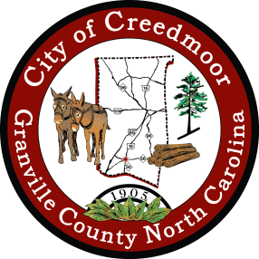

**LEGAL NOTICE**

**CITY OF CREEDMOOR**

**BOC REGULAR MEETING**

The City of Creedmoor BOC Regular scheduled meeting

will be held on **June 7, 2022, at 6 p.m.** in the Boardroom at

City Hall, 111 Masonic Street, Creedmoor, NC.

*Any questions should be directed to Barbara Rouse, City Clerk at

[brouse@cityofcreedmoor.org](mailto:brouse@cityofcreedmoor.org)