**MAYOR**

Robert V. Wheeler

**ACTING CITY MANAGER**

Michael S. Frangos

**COMMISSIONERS**

Emma Albright

Georgana Kicinski

Robert Way

Ed Mims

Edward Gleason

**CITY OF CREEDMOOR**

P.O. Box 765

111 Masonic Street

Creedmoor, NC 27522

[www.cityofcreedmoor.org](http://www.cityofcreedmoor.org)

(919) 528-3332

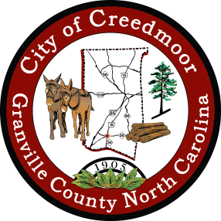

**NOTICE OF PUBLIC HEARING**

Notice is hereby given that a Public Hearing will be held by the City of Creedmoor Board of Commissioners for consideration of the fiscal year 2023 budget and the fiscal year 2023 fee and rate schedule.

The public hearing will be held as part of the regular agenda on **June 27, 2022**.The meeting begins at **6:00 p.m.** at City Hall, 111 Masonic Street, Creedmoor, NC

The public must contact the City Clerk in advance of the meeting at (919) 764-1010 or by emailing [brouse@cityofcreedmoor.org](mailto:brouse@cityofcreedmoor.org) to submit comments regarding the operating budget or the fee and rate schedule.

The draft operating budget was presented to the Creedmoor Board of Commissioners on June 16, 2022 and filed with the City Clerk. Members of the public may make an appointment to view the proposed budget at City Hall by contacting the City Clerk.

Published in the Butner-Creedmoor News on June 24, 2022 .