**MAYOR**

Robert V. Wheeler

**ACTING CITY MANAGER**

Michael S. Frangos

**COMMISSIONERS**

Emma Albright

Edward Gleason

Georgana Kicinski

Ed Mims

Robert Way

**CITY OF CREEDMOOR**

P.O. Box 765

111 Masonic Street

Creedmoor, NC 27522

[www.cityofcreedmoor.org](http://www.cityofcreedmoor.org)

(919) 528-3332

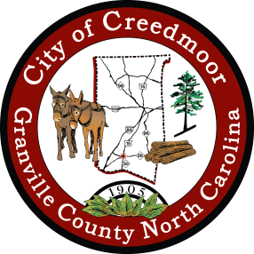

**Proclamation**

**Recognizing the fourth week in June as**

**Miss United States Agriculture Week.**

**Whereas:** On behalf of the City of Creedmoor, I recognize the fourth week in June as Miss United States Agriculture Week.

**Whereas:** Miss United States Agriculture started in 2014 in Alabama and promotes agriculture and everything agriculture; and

**Whereas:** Miss United States Agriculture encourages women in agriculture to teach and enhance the American Agricultural Story; and

**Whereas:** Miss United States Agriculture is truly to advocate for agriculture by using the crown and sash as an avenue to start conversations; and

**Whereas:** The City of Creedmoor also recognizes Katie Haynes as 2022 North Carolina People’s Choice Miss United States Agriculture; and

**Whereas:** The City of Creedmoor recognizes Katie Haynes as 2022 North Carolina Miss Agriculture Ambassador; and

**Now, Therefore I,** Robert V. Wheeler, on behalf of the Board of Commissioners of the City of Creedmoor, recognize the fourth week in June as Miss United States Agriculture Week.

IN WITNESS WHEREOF, I have hereunto set my hand and caused to be affixed the Seal of the City of Creedmoor this, the 7th day of June 2022.

Robert V. Wheeler, Mayor

ATTEST:

Barbara Rouse, City Clerk