**MAYOR**

Robert V. Wheeler

**ACTING CITY MANAGER**

Michael S. Frangos

**COMMISSIONERS**

Georgana Kicinski

Robert Way

Ed Mims

Emma Albright

Edward Gleason

**CITY OF CREEDMOOR**

P.O. Box 765

111 Masonic Street

Creedmoor, NC 27522

[www.cityofcreedmoor.org](http://www.cityofcreedmoor.org)

(919) 528-3332

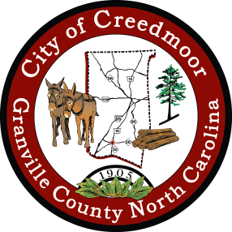

**LEGAL NOTICE**

**CITY OF CREEDMOOR**

**BOC SPECIAL MEETING –**

**Special Meeting Notice**

Please take notice that the City of Creedmoor Board of Commissioners will hold a Special Meeting on **August 25, 2022 at 6:00 P.M.**  at City Hall, in the Boardroom, 111 Masonic Street, Creedmoor, NC, and will immediately go into Closed Session pursuant to General Statute 143-318.11(a)(6) to interview candidates for the City Manager position.

*Any questions should be directed to Barbara Rouse, City Clerk to: [brouse@cityofcreedmoor.org](mailto:brouse@cityofcreedmoor.org)