**MAYOR**

Robert V. Wheeler

**CITY MANAGER**

Michael O. Turner

**COMMISSIONERS**

Georgana Kicinski

Robert Way

Ed Mims

Emma Albright

Edward Gleason

**CITY OF CREEDMOOR**

P.O. Box 765

111 Masonic Street

Creedmoor, NC 27522

[www.cityofcreedmoor.org](http://www.cityofcreedmoor.org)

(919) 528-3332

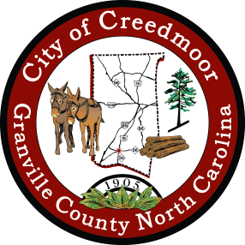

**LEGAL NOTICE**

**CITY OF CREEDMOOR**

**BOC SPECIAL MEETING –**

**Special Meeting Notice**

Please take notice that the City of Creedmoor Board of Commissioners will hold a Special Meeting on **September 29th , 2022 at 6:00 P.M.**  at City Hall, in the Boardroom, 111 Masonic Street, Creedmoor, NC to discuss the City Hall Renovation Project/Schematic Design package.

*Any questions should be directed to Barbara Rouse, City Clerk to: [brouse@cityofcreedmoor.org](mailto:brouse@cityofcreedmoor.org)