**MAYOR**

Robert V. Wheeler

**CITY MANAGER**

Michael O. Turner

**COMMISSIONERS**

Emma Albright

Edward Gleason

Georgana Kicinski

Ed Mims

Robert Way

**CITY OF CREEDMOOR**

P.O. Box 765

111 Masonic Street

Creedmoor, NC 27522

[www.cityofcreedmoor.org](http://www.cityofcreedmoor.org)

(919) 528-3332

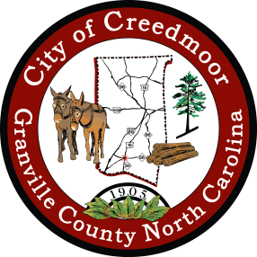

**LEGAL NOTICE**

**CITY OF CREEDMOOR**

**BOC SPECIAL MEETING –**

**Special Meeting Notice**

Please take notice that the City of Creedmoor Board of Commissioners will hold a Special Meeting on

**Thursday,** **November 10th, 2022 at 6:00 P.M.**

at City Hall, in the Boardroom, 111 Masonic Street, Creedmoor, NC, to go over changes to the City Hall Expansion Project, specifically Sanderford Street and the sally port on the PD building.

*Any questions should be directed to Barbara Rouse, City Clerk at: [brouse@cityofcreedmoor.org](mailto:brouse@cityofcreedmoor.org)