**MAYOR**

Robert V. Wheeler

**ACTING CITY MANAGER**

Michael O. Turner

**COMMISSIONERS**

Emma Albright

Edward Gleason

Georgana Kicinski

Robert Way

**CITY OF CREEDMOOR**

P.O. Box 765

111 Masonic Street

Creedmoor, NC 27522

[www.cityofcreedmoor.org](http://www.cityofcreedmoor.org)

(919) 528-3332

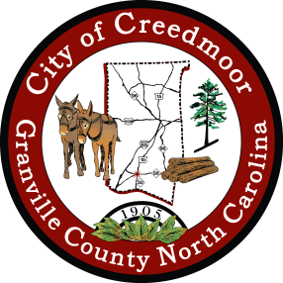

**LEGAL NOTICE**

**CITY OF CREEDMOOR**

**DEI TOWN HALL MEETING**

The City of Creedmoor DEI Advisory Board will be hosting a

~TOWN HALL ~

On Tuesday, January 31, 2023 at 6 p.m. to 8 p.m.

to be held at the

Creedmoor Community Center, Willow Oak Room,

116 Douglas Dr., Creedmoor, NC