**MAYOR**

Robert V. Wheeler

**ACTING CITY MANAGER**

Michael O. Turner

**COMMISSIONERS**

Emma Albright

Edward Gleason

Georgana Kicinski

Robert Way

Archer Wilkins

**CITY OF CREEDMOOR**

P.O. Box 765

111 Masonic Street

Creedmoor, NC 27522

[www.cityofcreedmoor.org](http://www.cityofcreedmoor.org)

(919) 528-3332

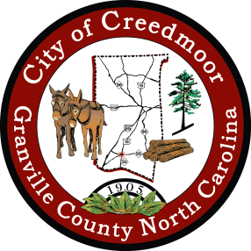

***NOTICE OF PUBLIC HEARING***

Notice is hereby given that a Public Hearing will be held by the City of Creedmoor Board of Commissioners for consideration of their ***Fiscal Year 2024 Budget***and the ***Fiscal Year 2024 Fee and Rate Schedule.***

The draft Operating Budget was presented to the Creedmoor Board of Commissioners on May 15th, 2023 and filed with the City Clerk. Members of the public may make an appointment to view the proposed budget at City Hall by contacting the City Clerk.

The Public Hearing will be held as part of the regular agenda on **Tuesday,** **June 6, 2023**.The meeting begins at **6:00 p.m.** at City Hall, 111 Masonic Street, Creedmoor, NC.

If you have any questions please contact the City Clerk at (919) 764-1010 or by emailing [brouse@cityofcreedmoor.org](mailto:brouse@cityofcreedmoor.org).

Published in the Butner-Creedmoor News on May 19, 2023.