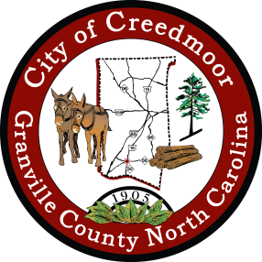

**PUBLIC HEARING NOTICE**

**The City of Creedmoor Board of Commissioners will hold a Public Hearing at their**

**January 2, 2024 BOC Meeting**

*6 p.m.*

*in the Boardroom at City Hall, 111 Masonic Street, Creedmoor, N.C.*

The City of Creedmoor Board of Commissioners will consider an ordinance amending the City Charter such that a mayor shall be elected every four (4) years instead of every two (2) years pursuant to N.C. Gen. Stat. § 160A-101(8)(a.).

*Any public comments or questions should be directed to Barbara Rouse, City Clerk to: [brouse@cityofcreedmoor.org](mailto:brouse@cityofcreedmoor.org)