**CITY OF CREEDMOOR**

P.O. Box 765

111 Masonic Street

Creedmoor, NC 27522

[www.cityofcreedmoor.org](http://www.cityofcreedmoor.org)

(919) 528-3332

**MAYOR**

Robert V. Wheeler

**CITY MANAGER**

Michael O. Turner

**COMMISSIONERS**

Emma Albright

Edward Gleason

Georgana Kicinski

Robert Way

Archer Wilkins

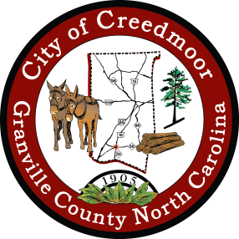

**Proclamation**

**National Night Out**

**October 1, 2024**

**WHEREAS,** National Night Out is a nationwide, annual community-building campaign that promotes police-community partnerships and neighborhood camaraderie to make our neighborhoods safer, more caring places to live; and

**WHEREAS,** National Night Out provides a unique opportunity for the City of Creedmoor to join forces with thousands of other communities across the country in promoting cooperative, police-community crime prevention efforts; and

**WHEREAS,** the City of Creedmoor community plays a vital role in assisting the Creedmoor Police Department through cooperative crime, drug and violence prevention efforts in the City of Creedmoor; and

**WHEREAS,** it is essential that all citizens of the City of Creedmoor to be aware of the importance of police-community partnerships and the impact that their participation can have on reducing crime and violence in the City of Creedmoor; and

**WHEREAS,** police-community partnerships, neighborhood safety, awareness and cooperation are important themes of the “National Night Out” program.

**NOW THEREFORE***,* I, Robert Wheeler, Mayor of the City of Creedmoor, do hereby call upon all citizens of the City of Creedmoor to join the Creedmoor Police Department and National Night Out in supporting the “Annual National Night Out” on October 1, 2024.

***IN TESTIMONY WHEREOF,*** *I have hereunto set my hand and caused to be affixed the seal of the City of Creedmoor this the 6th day of August, 2024.*

_____________________________

Robert V. Wheeler

Mayor

_______________________________

Barbara Rouse, NCCMC

City Clerk